Mrs. Roehrs’ Classroom News

Monday, November 13, 2017

www.mrsroehrskclassroom.weebly.com

C:\Documents and Settings\User\Local Settings\Temporary Internet Files\Content.IE5\KD7ETDD5\MC900290682[1].wmf

* We will be finishing up and reviewing the Ch. 4 concepts and having a test over the material before Thanksgiving break.
* Please continue to work on the following concepts at home: counting numbers, recognizing numbers, sorting objects in different ways, talking about things that are the same and not the same, and finding things that match.
* Help your child learn to determine if there is a difference of *one more, one less, or the same number of objects.* Being able to do this helps form the basis of simple addition/subtraction.
* **Encourage your child to count by 1’s and 10’s to 100. (Encourage your child to count by touching and saying each number.)**
* **Solving simple story problems is an excellent way to work on many skills at once.** For example: Five children came to school today. One of them went home sick. How many are still at school?
* We will be reviewing Ch. 3, which focused on children using non-standard units to measure, laying the foundation for the use of standard units in later grades.
* Please help your child have fun at home by measuring things at home with paperclips, noodles, ANYTHING. This is a fun unit of study.

***Math***

***Reading & Writing***

* ***In Reading***: we will work on the letter Pp, Pippa Pig. We will focus on recognizing, writing, and saying the sound for Pp.
* ***Phonemic Awareness:*** We will continue to work on **blending** **phonemes**. Phonemes are the sounds that represent each letter. I will give the children some sounds and ask them to blend the sounds to say a word. Example: /i/ /t/ What word is it? “it”
* ***Comprehension:*** We will continue to talk about what good readers do. This week I will talk about understanding characters that they read about in a story. I want them to try to figure out how the characters feel, what they are like, and why they do the things they do.
* ***Fluency:*** We will remind the children that good readers read at a rate that is similar to the way we talk. Even if your child reads a sentence slowly at first, it is important to have them go back and read it at a much quicker rate, like how they would talk.
* ***In Writing Workshop***, we will begin to work on writing lists in addition to our small moment stories. We are continuing to work on labeling our pictures. Have them help write your grocery list this week! They are becoming amazing writers!!!

C:\Documents and Settings\User\Local Settings\Temporary Internet Files\Content.IE5\ECXV6L2L\MC900437990[1].wmf

Popcorn will be sold every Friday for 50 cents.

for 50 cents a bag.

C:\Documents and Settings\User\Local Settings\Temporary Internet Files\Content.IE5\RNXM3JYJ\MC900234605[1].wmf

C:\Documents and Settings\User\Local Settings\Temporary Internet Files\Content.IE5\KD7ETDD5\MC900442036[1].wmf

1. **Library Books:** Please be sure to return your child’s library book every week by Thursday. If they forget their book, they cannot check out another one until it is returned. They get so sad about this. Thanks for your help.
2. **Popcorn money:** Please send in money for popcorn at any time. You can also pay ahead if that makes it easier for you.
3. **End of Day Dismissal:** If your child changes their afternoon routine for going home, please let me know by sending in a note, or calling the office at 775-2280.
4. **Half Day of School:** Nov. 22nd, Report cards go home
5. **No School:** Thanksgiving Break, Nov. 23rd and 24th
6. **Book Orders Due:** Nov. 13th
7. **Dentists R Us:** Nov. 16th, Students must return the appropriate paperwork to be seen by the dentist
8. **Book Nic:** Held from 12:00-12:45. Come eat lunch with your child and read books!

SPECIALS SCHEDULE

Monday – Art

Tuesday – Art and P.E.

Wednesday – Computers and Music

Thursday – P.E. and Library

Friday – Music

C:\Documents and Settings\User\Local Settings\Temporary Internet Files\Content.IE5\MZVQAG52\MC900078766[1].wmf

`

**Cold weather is here!**

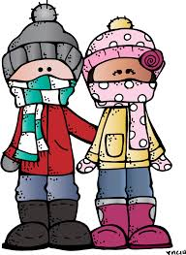

Your child should come to school with a **WARM** coat, hat, and gloves. When it snows, boots and snow pants will be required to play on the playground. Otherwise, they stay on the black top.

Book Nic

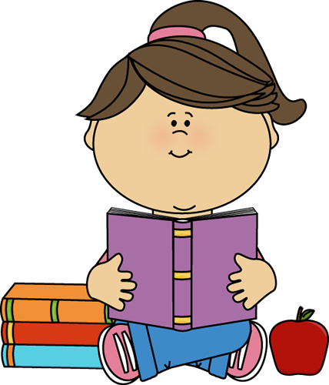

12:00-12:45

Bring a lunch for you and your child or order one from the cafeteria. Have a little picnic and enjoy reading together!

**PLEASE practice letters, sounds, and sight words at home with your child.**

