Mrs. Roehrs’ Classroom News

Monday, November 20, 2017

www.mrsroehrskclassroom.weebly.com

C:\Documents and Settings\User\Local Settings\Temporary Internet Files\Content.IE5\KD7ETDD5\MC900290682[1].wmf

* We will be completing a few Thanksgiving themed math activities.
  + Counting the dots on dominoes and sorting them by number
  + Counting the dots on two dice and adding them together
* Continue to practice counting, writing, and identifying numbers.

***Math***

***Reading & Writing***

***Continued from Last Week***

* ***In Reading***: we will work on the letter Pp, Pippa Pig. We will focus on recognizing, writing, and saying the sound for Pp.
* ***Phonemic Awareness:*** We will continue to work on **blending** **phonemes**. Phonemes are the sounds that represent each letter. I will give the children some sounds and ask them to blend the sounds to say a word. Example: /i/ /t/ What word is it? “it”
* ***Comprehension:*** We will continue to talk about what good readers do. This week I will talk about understanding characters that they read about in a story. I want them to try to figure out how the characters feel, what they are like, and why they do the things they do.
* ***Fluency:*** We will remind the children that good readers read at a rate that is similar to the way we talk. Even if your child reads a sentence slowly at first, it is important to have them go back and read it at a much quicker rate, like how they would talk.
* ***In Writing Workshop***, we will continue to work on writing lists in addition to our small moment stories. We are continuing to work on labeling our pictures. We will focus on making lists of all kinds; favorite foods, Christmas lists, what we are thankful for, etc. They are doing a wonderful job!

C:\Documents and Settings\User\Local Settings\Temporary Internet Files\Content.IE5\ECXV6L2L\MC900437990[1].wmf

Happy Thanksgiving!

Have a great holiday with loved ones!

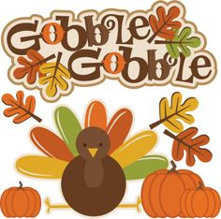

Popcorn will be sold every Friday for 50 cents.

for 50 cents a bag.

C:\Documents and Settings\User\Local Settings\Temporary Internet Files\Content.IE5\RNXM3JYJ\MC900234605[1].wmf

C:\Documents and Settings\User\Local Settings\Temporary Internet Files\Content.IE5\KD7ETDD5\MC900442036[1].wmf

1. **Library Books:** Please be sure to return your child’s library book every week by Thursday. If they forget their book, they cannot check out another one until it is returned. They get so sad about this. Thanks for your help.
2. **Popcorn money:** Please send in money for popcorn at any time. You can also pay ahead if that makes it easier for you.
3. **End of Day Dismissal:** If your child changes their afternoon routine for going home, please let me know by sending in a note, or calling the office at 775-2280.
4. **Half Day of School:** Nov. 22nd, Report cards go home
5. **No School:** Thanksgiving Break, Nov. 23rd and 24th
6. **Book Orders Due:** Dec. 8th
7. **Book Nic:** Held from 12:00-12:45. Come eat lunch with your child and read books!
8. **Christmas Outreach Stocking Items:** Due by Dec. 4th

SPECIALS SCHEDULE

Monday – Art

Tuesday – Art and P.E.

Wednesday – Computers and Music

Thursday – P.E. and Library

Friday – Music

C:\Documents and Settings\User\Local Settings\Temporary Internet Files\Content.IE5\MZVQAG52\MC900078766[1].wmf

`

**Cold weather is here!**

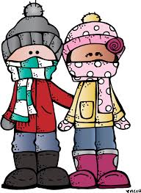

Your child should come to school with a **WARM** coat, hat, and gloves. When it snows, boots and snow pants will be required to play on the playground. Otherwise, they stay on the black top.

Book Nic



12:00-12:45

Bring a lunch for you and your child or order one from the cafeteria. Have a little picnic and enjoy reading together!

**Christmas Outreach Stockings**

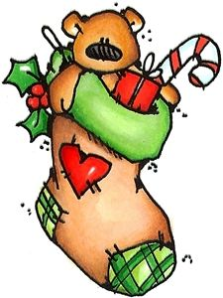

**We are collecting items for children’s stockings. Some suggested items are:**

24 crayons, glue sticks, thin coloring/activity books, playdough, bubbles, small cars, pencils, erasers, stickers, card games, misc. school supplies, jump ropes, jacks, mini figures (ex. Dinosaurs), small puzzles, glow sticks, small balls, personal care items, etc.