Mrs. Roehrs’ Classroom News

Monday, November 27, 2017

www.mrsroehrskclassroom.weebly.com

***Reading & Writing***

* ***In Reading***: we will review letters S, C, M, T, P, A. I sent home a sheet of sight words that your child should be practicing at home. They should be able to say them quickly and no sounding out.
* ***Phonemic Awareness:*** We will continue to work on **blending** **phonemes**. Phonemes are the sounds that represent each letter. I will give the children some sounds and ask them to blend the sounds to say a word. Example: /j/ /e/ /t/ What word is it? “jet”
* ***Comprehension:*** We will continue to talk about what good readers do. This week I will talk about naming the important parts of a story as they read. Doing this helps them to understand the story better. It also helps them to ***retell*** it to others. **Retelling** is a very important skill and one that you can do with your child at home. Ask questions like: *Who is this story about? Where does this story take place? What happened first, next, last?*
* ***Fluency:*** We will remind the children that good readers read with expression. We have talked about ***quotation marks*** and how it makes the story more interesting when they change their voice for the character that is speaking.
* ***In Writing Workshop***, we will begin to work on writing lists that can later become a pattern book. We are also encouraging your child to label all of their pictures when writing. We have also been reading lots of books and talking about different types of lists.

C:\Documents and Settings\User\Local Settings\Temporary Internet Files\Content.IE5\KD7ETDD5\MC900290682[1].wmf

* This week we will be starting a new, but very short chapter on “Size and Position.” The children need to understand that objects can be measured by various attributes. We will use the words: ***smaller, bigger, same size****.* They will also learn to describe objects and their relative position to one another. We will use the words: ***on top of, under, next to, behind, in front of, and inside.***
* **Encourage your child to count by 1’s and 10’s to 100.**
* **Help your child count and write their numbers to 20. Be sure they are forming their numbers correctly. Reversals are normal for now.**
* **Solving simple story problems is an excellent way to work on many skills at once.** For example: Six birds were sitting in a tree. Three flew away. How many were still sitting in the tree?

C:\Documents and Settings\User\Local Settings\Temporary Internet Files\Content.IE5\ECXV6L2L\MC900437990[1].wmf

***Math***

C:\Documents and Settings\User\Local Settings\Temporary Internet Files\Content.IE5\RNXM3JYJ\MC900234605[1].wmf

Popcorn will be sold every Friday for 50 cents.

for 50 cents a bag.

C:\Documents and Settings\User\Local Settings\Temporary Internet Files\Content.IE5\Q6BRRLEU\MC900059854[1].wmf

Parents and Guardians:

Please let me know of any religious or personal beliefs I need to be aware of as we approach this holiday season. Thank you, in advance, for your help!

C:\Documents and Settings\User\Local Settings\Temporary Internet Files\Content.IE5\MZVQAG52\MC900078766[1].wmf

SPECIALS SCHEDULE

Monday – Art

Tuesday – Art and P.E.

Wednesday – Computers and Music

Thursday – P.E. and Library

Friday – Music

C:\Documents and Settings\User\Local Settings\Temporary Internet Files\Content.IE5\KD7ETDD5\MC900442036[1].wmf

1. **Library Books:** Please be sure to return your child’s library book every week by Tuesday. If they forget their book, they cannot check out another one until it is returned. They get so sad about this. Thanks for your help.
2. **Popcorn Money:** Please send in money for popcorn at any time. You can also pay ahead if that makes it easier for you.
3. **End of Day Dismissal:** If your child changes their afternoon routine for going home, please let me know by sending in a note, or calling the office at 775-2280.
4. **Book Orders Due:** Dec. 8th. Books make great holiday gifts. Please let me know if your order contains a gift for your child. I can call you when the order arrives and it can be picked up in the office.
5. **Christmas Break:** Dec. 22nd-Jan. 1st
6. **Reading Logs Due:** Dec. 21st

`



Please let me know if you would be willing to donate one of the ingredients needed for “Reindeer Chow.” We will be doing an activity with this fun snack mix on Thursday, December 21st . We need one package of each of the following snacks:

Pretzel Sticks

Goldfish

Mini Marshmallows

Honeycomb Cereal

Large Bag of Plain M & M’s

The kids have a great time sorting, counting, and eating these yummy treats!

**Keep working on sight words. Many students are so excited to tell me the words that they know. Keep up the good work!**

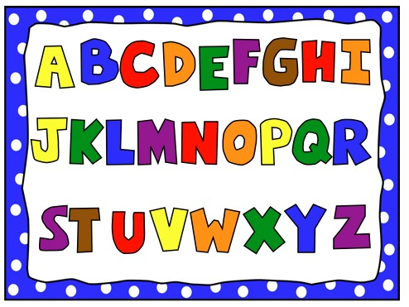

**Holiday Party**



I plan to have a Holiday party for the children during the last week before the holiday break. We will be making gingerbread houses during the party. Please see the attached supply list. If you cannot supply the items assigned to your child, please let me know as soon as possible and I will be sure to make other arrangements. I am still working on the final details for the party. As of right now, the party will be on December 20th. I am still looking at the schedule to finalize the time. I will let you know as soon as possible. Thank you for your support!

**Cold weather is here!**

Your child should come to school with a **warm coat**, **hat**, and **gloves**. When it snows, boots and snow pants will be required to play on the playground. Otherwise, they stay on the black top.

**Please label all clothing with**

**first and last names!**

C:\Documents and Settings\User\Local Settings\Temporary Internet Files\Content.IE5\MZVQAG52\MC900053398[1].wmf

**Note**:

I am really stressing good hand writing; good letter and number formation.