Mrs. Roehrs’ Classroom News

Monday, October 30, 2017

www.mrsroehrskclassroom.weebly.com

C:\Documents and Settings\User\Local Settings\Temporary Internet Files\Content.IE5\KD7ETDD5\MC900290682[1].wmf

* We will begin Chapter 4: Counting and numbers 0 to 10 which includes concepts such as – 1.“composing and decomposing numbers” – basic addition and subtraction but ONLY USING manipulatives and no numbers to get started; 2. counting and ordering numbers; 3. using our fingers and toes to count on; 4. same number and more; less than; 5. How many in all?
* **Encourage your child to count by 1’s and 10’s to 100.**
* **Help your child count and write their numbers to 20. Be sure they are forming their numbers correctly.**
* **Solving simple story problems is an excellent way to work on many skills at once.** For example: Five children came to school today. One of them went home sick. How many are still at school?
* Help your child by allowing them to touch, examine, and compare objects to develop awareness of attributes such as length, size, and weight.

***Reading & Writing***

* ***In Reading***: we will be working on the letter Tt, Tiggy Tiger. We have 2 letter “friends” – Timothy Tiger from Zoo-Phonics and Tiggy Tiger from our Houghton Mifflin reading program. We will focus on recognizing, writing, and saying the sound for Tt.
* ***Phonemic Awareness:*** We will start working on blending **onset and rime**. The “onset” is the first sound of a word, and “rime” is the rest of the word. We will also begin to *segment* onset and rime. I will say a word and ask the students to break it into two parts – the first sound and then the sounds for the rest of the word. For example: ***get.***  **/g/…../et/** Please continue to work on this at home.
* ***Comprehension:*** We will continue to talk about what good readers do. This week I will talk about understanding characters that they read about in a story. I want them to try to figure out how the characters feel, what they are like, and why they do the things they do.
* ***Fluency:*** We will remind the children that good readers pause when they come to a period at the end of a sentence. Pausing before continuing to read the next sentence makes the story easier for them to understand.
* ***In Writing Workshop***, we will continue to work on writing stories with many details. We will continue to practice stretching our words and writing the sounds that we hear. We are focusing on things that we are thankful for and writing why we feel that way. They are doing a great job!

C:\Documents and Settings\User\Local Settings\Temporary Internet Files\Content.IE5\ECXV6L2L\MC900437990[1].wmf

***Math***

C:\Documents and Settings\User\Local Settings\Temporary Internet Files\Content.IE5\Q6BRRLEU\MC900435963[1].wmf

**Halloween Party**

**Date: October 31st**

**Parade with costumes: 1:45**

**Party: 2:30-3:15**

**Students will wear costumes home, unless we are instructed otherwise by parents.**

Popcorn will be sold every Friday for 50 cents.

for 50 cents a bag.

C:\Documents and Settings\User\Local Settings\Temporary Internet Files\Content.IE5\RNXM3JYJ\MC900234605[1].wmf

SPECIALS SCHEDULE

Monday – Art

Tuesday – Art and P.E.

Wednesday – Computers and Music

Thursday – P.E. and Library

Friday – Music

C:\Documents and Settings\User\Local Settings\Temporary Internet Files\Content.IE5\KD7ETDD5\MC900442036[1].wmf

1. **Library Books:** Please be sure to return your child’s library book every week by Thursday. If they forget their book, they cannot check out another one until it is returned. They get so sad about this. Thanks for your help.
2. **Popcorn money:** Please send in money for popcorn at any time. You can also pay ahead if that makes it easier for you.
3. **End of Day Dismissal:** If your child changes their afternoon routine for going home, please let me know by sending in a note, or calling the office at 775-2280.
4. **No School:** Nov. 7th, Election Day
5. **No School:** Thanksgiving Break, Nov. 23rd and 24th
6. **Book Orders Due:** Nov. 13th

C:\Documents and Settings\User\Local Settings\Temporary Internet Files\Content.IE5\MZVQAG52\MC900078766[1].wmf

`

**Halloween Party Donations**



**Thank you to everyone who signed up to donate supplies for our party!**

**We really appreciate it!**

If you choose to send in candy for your child to pass out, it will be sent home. The cookies will be decorated in the morning by the students to be enjoyed during the party. The party is shortly after lunch so they shouldn’t need a lot of snacks.

**Please keep in mind the restrictions due to allergies when buying any snacks or treats for the party.**

**Cold weather is here!**

Your child should come to school with a coat, hat, and gloves. When it snows, boots and snow pants will be required to play on the playground. Otherwise, they stay on the black top.

**PLEASE practice letters, sounds, and sight words at home with your child.**

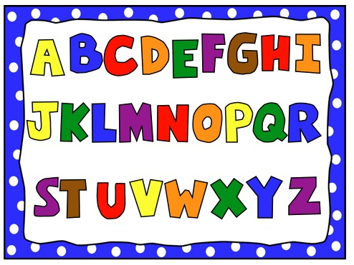

**[](http://3.bp.blogspot.com/-2cHiNfnyJDw/UCvdzamOPFI/AAAAAAAAGcw/nPfRrZYW8tE/s1600/BoxTopsLogo.jpg)**

Box Tops for Education Please continue to collect! You may send them in at any time. They can be taped onto a paper or in a Ziploc bag.